**Docker – A Single Source of Truth (or Lies) Kapil Khanal**

**Motivation**



1. First, as additional motivation, read <https://www.datacamp.com/community/tech/session-management>, which details DataCamp’s move to and usage of Docker. Write a paragraph summarizing the post.

* Datacamp used Docker to reduce the complexity of installing different packages and dependencies of their different course . Before they have Rserve running to support R sessions but then they got across the problem where they have the issues of different dependencies and the system was lagging because of too many installation files. They also developed the NodeJS service to have a small docker container for each course this way only the required dependcies are installed. They found this architecture scalable.

**Prerequisites**



1. Now it is time to read up on the details of the DOCKERFILE. Please read <https://www.digitalocean.com/community/tutorials/docker-explained-using-dockerfiles-to-automate-building-of-images>. Make a list of Docker commands and what they are used for.

=>

Belor the list of Commands

1. ADD

The ADD command gets two arguments: a source and a destination. It basically copies the files from the source on the host into the container's own filesystem at the set destination

1. CMD

The command CMD, similarly to RUN, can be used for executing a specific command.

1. ENTRYPOINT

ENTRYPOINT argument sets the concrete default application that is used every time a container is created using the image

1. ENV

The ENV command is used to set the environment variables (one or more). These variables consist of “key value” pairs which can be accessed within the container by scripts and applications alike. This functionality of Docker offers an enormous amount of flexibility for running programs.

1. Expose

The EXPOSE command is used to associate a specified port to enable networking between the running process inside the container and the outside world (i.e. the host).

1. FROM

FROM directive is probably the most crucial amongst all others for Dockerfiles. It defines the base image to use to start the build process.

1. MAINTAINER

non-executing command declares the author, hence setting the author field of the images. It should come nonetheless after FROM.Better at the Top.

1. RUN

 It takes a command as its argument and runs it to form the image

1. USER

used to set the UID (or username) which is to run the container based on the image being built.

1. VOLUME

The VOLUME command is used to enable access from your container to a directory on the host machine (i.e. mounting it).

1. WORKDIR

The WORKDIR directive is used to set where the command defined with CMD is to be executed.

**Down the rabbit hole**

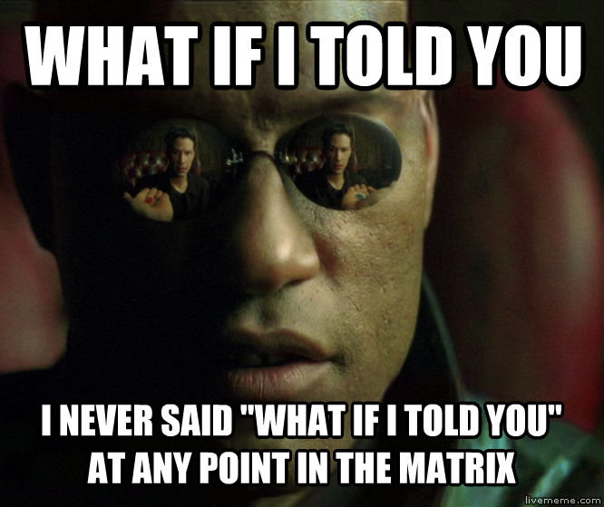

1. We will be using <https://github.com/jupyter/docker-stacks/tree/master/pyspark-notebook> to standardize our computing environment. It is your job to dig in and understand how the jupyter docker containers on this page are related. To accomplish this task
   1. **Step 1 –** Finding the bottom.
      1. Inspect the DOCKERFILE for the pyspark-notebook
         1. Note the FROM source
            1. Goto that container (click on docker-stacks to see all containers)

Note the FROM clause in that container

Goto that container (click on docker-stacks to see all containers)

Note the FROM clause in that container

… Where does it end

* *It goes from pyspark notebook Docker file to Scipy notebook Docker file to Minimal notebook dockerfile to base notebook dcoker file to* ***ubuntu:bionic-20180526@sha256:c8c275751219dadad8fa56b3ac41ca6cb22219ff117ca98fe82b42f24e1ba64e***

**Start from the bottom**

 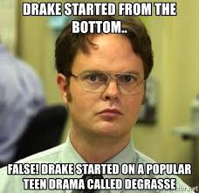

1. Understand the pyspark-notebook installation details. Start with the bottom dockerfile. For each DOCKERFILE in the chain (that leads to pyspark-notebook), read and summarize what each code block accomplished. Document your work with screen shots along with your summaries.
2. Base container 

Base container installs Anaconda and other permission issues for adding users to the container on some Ubuntu machine in the cloud

1. Minimal Notebook 

Docker file on Minimal notebook installs libraries and packages necessary for fully functional server.

1. Scipy Notebook Docker file

This installs the scientific python libraries needed for data science tasks



1. Pyspark notebools

Installs and Initiates the spark connection.



1. What are the advantages to structuring the containers in this way? Are there any disadvantages?

* The advantage of using this way is we have all the same dependencies that we specify. This will prevent hassle with different versions of dependencies

**Docker Nirvana**



1. Write a few sentences summarize how using this docker container should help fix our issues.

* We don’t have to worry about statements like “ This works on Todd’s machine but not on mine!“